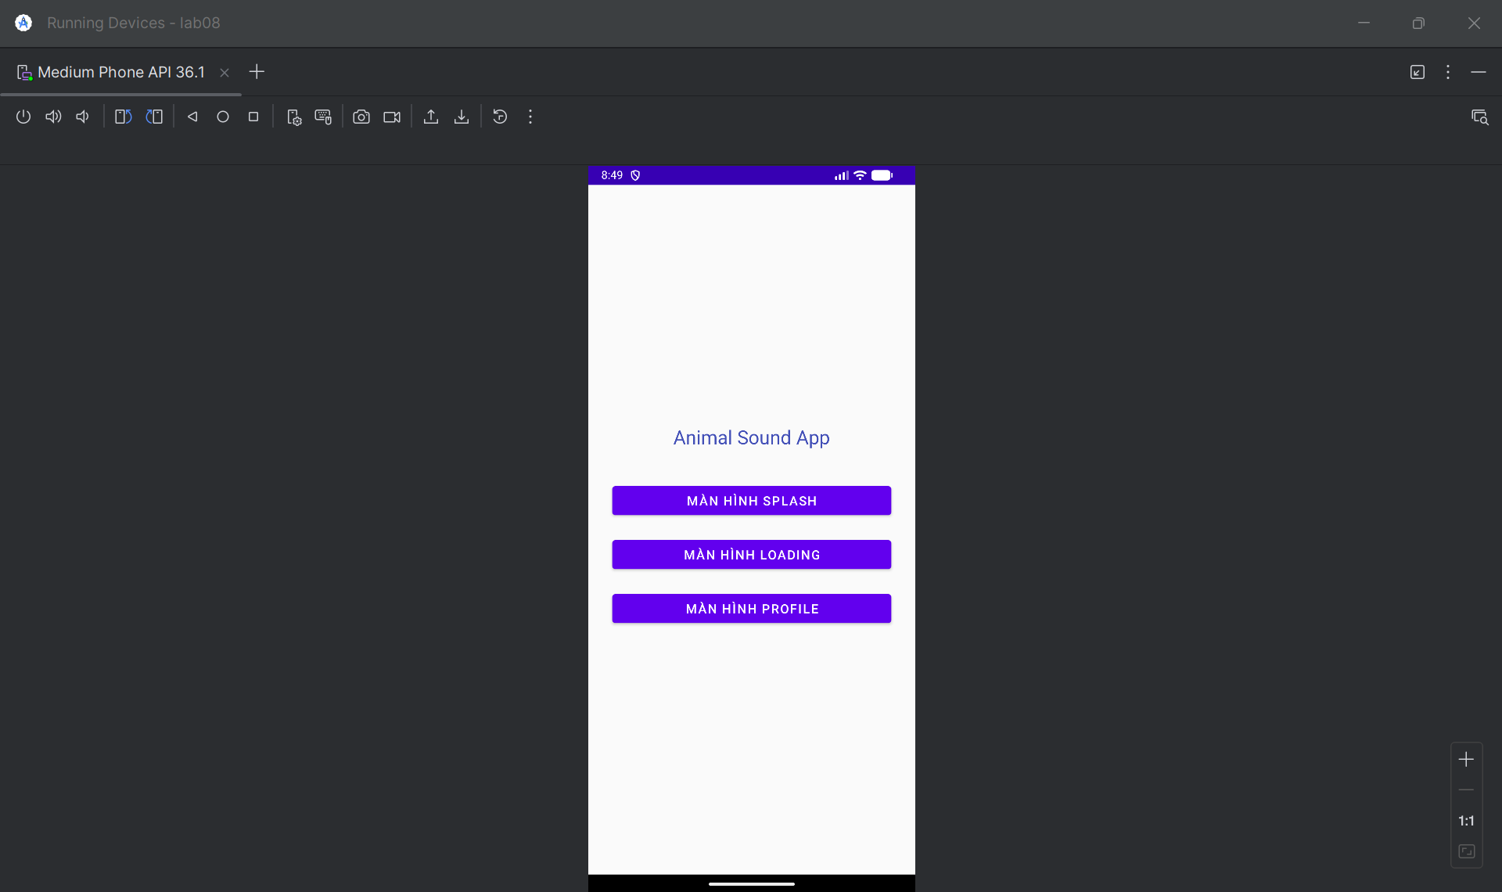

M000ActSplash

package com.example.lab08;  
  
import android.graphics.Color;  
import android.os.Bundle;  
import android.widget.ImageView;  
import android.widget.LinearLayout;  
import androidx.appcompat.app.AppCompatActivity;  
import java.util.Random;  
  
public class M000ActSplash extends AppCompatActivity {  
  
 private LinearLayout rootLayout;  
 private ImageView imageView;  
  
 @Override  
 protected void onCreate(Bundle savedInstanceState) {  
 super.onCreate(savedInstanceState);  
 setContentView(R.layout.*m001_act_splash*);  
  
 initViews();  
 setRandomBackgroundAndIcon();  
 }  
  
 private void initViews() {  
 rootLayout = findViewById(R.id.*root_layout*);  
 imageView = findViewById(R.id.image_view);  
 }  
  
 private void setRandomBackgroundAndIcon() {  
 int[] colors = {  
 Color.*parseColor*("#FF4181"),  
 Color.*parseColor*("#424FB7"),  
 Color.*parseColor*("#3C4647"),  
 Color.*parseColor*("#FF03DAC5"),  
 Color.*parseColor*("#FF018786")  
 };  
  
 int[] icons = {  
 R.drawable.*ic_penguin*,  
 R.drawable.*ic_phone*,  
 R.drawable.*ic_email*,  
 R.drawable.*ic_star* };  
  
 Random random = new Random();  
 int randomColor = colors[random.nextInt(colors.length)];  
 int randomIcon = icons[random.nextInt(icons.length)];  
  
 rootLayout.setBackgroundColor(randomColor);  
 imageView.setImageResource(randomIcon);  
 }  
}

M001ActProfile

package com.example.lab08;  
  
import android.content.Intent;  
import android.net.Uri;  
import android.os.Bundle;  
import android.view.View;  
import android.widget.ImageView;  
import android.widget.TextView;  
import androidx.appcompat.app.AppCompatActivity;  
  
public class M001ActProfile extends AppCompatActivity {  
  
 private ImageView phoneIcon1, phoneIcon2;  
 private TextView txtPhone1, txtPhone2;  
  
 @Override  
 protected void onCreate(Bundle savedInstanceState) {  
 super.onCreate(savedInstanceState);  
 setContentView(R.layout.*m001_act_profile*);  
  
 initViews();  
 setupClickListeners();  
 }  
  
 private void initViews() {  
 phoneIcon1 = findViewById(R.id.phone_icon1);  
 phoneIcon2 = findViewById(R.id.phone_icon2);  
 txtPhone1 = findViewById(R.id.txt_phone1);  
 txtPhone2 = findViewById(R.id.txt_phone2);  
 }  
  
 private void setupClickListeners() {  
 phoneIcon1.setOnClickListener(new View.OnClickListener() {  
 @Override  
 public void onClick(View v) {  
 String phoneNumber = txtPhone1.getText().toString().replaceAll("[^0-9]", "");  
 makePhoneCall(phoneNumber);  
 }  
 });  
  
 phoneIcon2.setOnClickListener(new View.OnClickListener() {  
 @Override  
 public void onClick(View v) {  
 String phoneNumber = txtPhone2.getText().toString().replaceAll("[^0-9]", "");  
 makePhoneCall(phoneNumber);  
 }  
 });  
  
 txtPhone1.setOnClickListener(new View.OnClickListener() {  
 @Override  
 public void onClick(View v) {  
 String phoneNumber = txtPhone1.getText().toString().replaceAll("[^0-9]", "");  
 makePhoneCall(phoneNumber);  
 }  
 });  
  
 txtPhone2.setOnClickListener(new View.OnClickListener() {  
 @Override  
 public void onClick(View v) {  
 String phoneNumber = txtPhone2.getText().toString().replaceAll("[^0-9]", "");  
 makePhoneCall(phoneNumber);  
 }  
 });  
 }  
  
 private void makePhoneCall(String phoneNumber) {  
 Intent intent = new Intent(Intent.*ACTION_DIAL*);  
 intent.setData(Uri.*parse*("tel:" + phoneNumber));  
 startActivity(intent);  
 }  
}

MainActivity

package com.example.lab08;  
  
import android.content.Intent;  
import android.os.Bundle;  
import android.view.View;  
import android.widget.Button;  
import androidx.appcompat.app.AppCompatActivity;  
  
public class MainActivity extends AppCompatActivity {  
  
 private Button btnSplash, btnLoading, btnProfile;  
  
 @Override  
 protected void onCreate(Bundle savedInstanceState) {  
 super.onCreate(savedInstanceState);  
 setContentView(R.layout.*activity_main*);  
  
 initViews();  
 setupClickListeners();  
 }  
  
 private void initViews() {  
 btnSplash = findViewById(R.id.*btn_splash*);  
 btnLoading = findViewById(R.id.*btn_loading*);  
 btnProfile = findViewById(R.id.*btn_profile*);  
 }  
  
 private void setupClickListeners() {  
 btnSplash.setOnClickListener(new View.OnClickListener() {  
 @Override  
 public void onClick(View v) {  
 navigateToSplashScreen();  
 }  
 });  
  
 btnLoading.setOnClickListener(new View.OnClickListener() {  
 @Override  
 public void onClick(View v) {  
 navigateToLoadingScreen();  
 }  
 });  
  
 btnProfile.setOnClickListener(new View.OnClickListener() {  
 @Override  
 public void onClick(View v) {  
 navigateToProfileScreen();  
 }  
 });  
 }  
  
 private void navigateToSplashScreen() {  
 Intent intent = new Intent(MainActivity.this, M000ActSplash.class);  
 startActivity(intent);  
 }  
  
 private void navigateToLoadingScreen() {  
 Intent intent = new Intent(MainActivity.this, M000ActSplash.class);  
 startActivity(intent);  
 }  
  
 private void navigateToProfileScreen() {  
 Intent intent = new Intent(MainActivity.this, M001ActProfile.class);  
 startActivity(intent);  
 }  
  
 @Override  
 public void onBackPressed() {  
 super.onBackPressed();  
 finish();  
 }  
}

layout

main_activity

<?xml version="1.0" encoding="utf-8"?>  
<LinearLayout  
 xmlns:android="http://schemas.android.com/apk/res/android"  
 android:layout_width="match_parent"  
 android:layout_height="match_parent"  
 android:orientation="vertical"  
 android:gravity="center"  
 android:padding="20dp"  
 android:background="@color/gray_light">  
  
 <TextView  
 android:layout_width="wrap_content"  
 android:layout_height="wrap_content"  
 android:text="Animal Sound App"  
 android:textSize="24sp"  
 android:textColor="@color/indigo"  
 android:layout_marginBottom="30dp" />  
  
 <Button  
 android:id="@+id/btn_splash"  
 android:layout_width="match_parent"  
 android:layout_height="wrap_content"  
 android:layout_margin="10dp"  
 android:text="Màn hình Splash"  
 android:textSize="16sp" />  
  
 <Button  
 android:id="@+id/btn_loading"  
 android:layout_width="match_parent"  
 android:layout_height="wrap_content"  
 android:layout_margin="10dp"  
 android:text="Màn hình Loading"  
 android:textSize="16sp" />  
  
 <Button  
 android:id="@+id/btn_profile"  
 android:layout_width="match_parent"  
 android:layout_height="wrap_content"  
 android:layout_margin="10dp"  
 android:text="Màn hình Profile"  
 android:textSize="16sp" />  
  
</LinearLayout>

Item_loading

<?xml version="1.0" encoding="utf-8"?>  
<LinearLayout  
 xmlns:android="http://schemas.android.com/apk/res/android"  
 android:layout_width="match_parent"  
 android:layout_height="match_parent"  
 android:gravity="center"  
 android:background="#BF000000"  
 android:orientation="vertical">  
  
 <ProgressBar  
 android:layout_width="60dp"  
 android:layout_height="60dp"  
 android:indeterminateTint="@color/white" />  
  
 <TextView  
 android:layout_width="wrap_content"  
 android:layout_height="wrap_content"  
 android:layout_marginTop="10dp"  
 android:fontFamily="sans-serif-light"  
 android:text="@string/txt_loading"  
 android:textColor="@color/white"  
 android:textSize="24sp" />  
  
</LinearLayout>

M001_act_profile

<?xml version="1.0" encoding="utf-8"?>  
<LinearLayout  
 xmlns:android="http://schemas.android.com/apk/res/android"  
 xmlns:app="http://schemas.android.com/apk/res-auto"  
 xmlns:tools="http://schemas.android.com/tools"  
 android:layout_width="match_parent"  
 android:layout_height="match_parent"  
 android:background="@color/gray_light"  
 android:orientation="vertical">  
  
 <FrameLayout  
 android:layout_width="match_parent"  
 android:layout_height="350dp">  
  
 <ImageView  
 android:layout_width="match_parent"  
 android:layout_height="300dp"  
 android:scaleType="centerCrop"  
 android:src="@drawable/bg_avatar"  
 tools:ignore="ContentDescription" />  
  
 <TextView  
 android:layout_width="wrap_content"  
 android:layout_height="wrap_content"  
 android:layout_gravity="bottom"  
 android:layout_marginStart="70dp"  
 android:layout_marginBottom="90dp"  
 android:fontFamily="sans-serif"  
 android:text="@string/txt_name"  
 android:textColor="@color/white"  
 android:textSize="40sp" />  
  
 <ImageView  
 android:layout_width="80dp"  
 android:layout_height="80dp"  
 android:layout_gravity="end|bottom"  
 android:layout_marginEnd="20dp"  
 android:layout_marginBottom="10dp"  
 android:background="@drawable/bg_oval"  
 android:padding="20dp"  
 android:src="@drawable/ic_star"  
 app:tint="@color/white"  
 tools:ignore="ContentDescription" />  
  
 </FrameLayout>  
  
 <TableRow  
 android:layout_width="match_parent"  
 android:layout_height="wrap_content"  
 android:padding="20dp">  
  
 <ImageView  
 android:id="@+id/phone_icon1"  
 android:layout_width="60dp"  
 android:layout_height="60dp"  
 android:padding="10dp"  
 android:src="@drawable/ic_phone"  
 app:tint="@color/indigo"  
 tools:ignore="ContentDescription"/>  
  
 <LinearLayout  
 android:layout_width="match_parent"  
 android:layout_height="wrap_content"  
 android:layout_marginStart="30dp"  
 android:orientation="vertical">  
  
 <TextView  
 android:id="@+id/txt_phone1"  
 android:layout_width="match_parent"  
 android:layout_height="wrap_content"  
 android:text="@string/txt_phone1"  
 android:textColor="@color/gray_dark"  
 android:textSize="20sp" />  
  
 <TextView  
 android:layout_width="match_parent"  
 android:layout_height="wrap_content"  
 android:layout_marginTop="5dp"  
 android:text="@string/txt_title_mobile"  
 android:textColor="@color/gray_mid"  
 android:textSize="18sp" />  
  
 <TextView  
 android:id="@+id/txt_phone2"  
 android:layout_width="match_parent"  
 android:layout_height="wrap_content"  
 android:layout_marginTop="30dp"  
 android:text="@string/txt_phone2"  
 android:textColor="@color/gray_dark"  
 android:textSize="20sp" />  
  
 <TextView  
 android:layout_width="match_parent"  
 android:layout_height="wrap_content"  
 android:layout_marginTop="5dp"  
 android:text="@string/txt_title_mobile"  
 android:textColor="@color/gray_mid"  
 android:textSize="18sp" />  
  
 <View  
 android:layout_width="match_parent"  
 android:layout_height="0.5dp"  
 android:layout_marginTop="30dp"  
 android:background="@color/gray_mid"/>  
  
 </LinearLayout>  
  
 </TableRow>  
  
 <TableRow  
 android:layout_width="match_parent"  
 android:layout_height="wrap_content"  
 android:padding="20dp">  
  
 <ImageView  
 android:id="@+id/phone_icon2"  
 android:layout_width="60dp"  
 android:layout_height="60dp"  
 android:padding="10dp"  
 android:src="@drawable/ic_email"  
 app:tint="@color/indigo"  
 tools:ignore="ContentDescription"/>  
  
 <LinearLayout  
 android:layout_width="match_parent"  
 android:layout_height="match_parent"  
 android:layout_marginStart="30dp"  
 android:orientation="vertical">  
  
 <TextView  
 android:layout_width="match_parent"  
 android:layout_height="wrap_content"  
 android:text="@string/txt_email"  
 android:textColor="@color/gray_dark"  
 android:textSize="20sp" />  
  
 <TextView  
 android:layout_width="match_parent"  
 android:layout_height="wrap_content"  
 android:layout_marginTop="5dp"  
 android:text="@string/txt_title_mobile"  
 android:textColor="@color/gray_mid"  
 android:textSize="18sp" />  
  
 </LinearLayout>  
  
 </TableRow>  
  
</LinearLayout>

M001_act_splash

<?xml version="1.0" encoding="utf-8"?>  
<FrameLayout  
 xmlns:android="http://schemas.android.com/apk/res/android"  
 xmlns:tools="http://schemas.android.com/tools"  
 android:id="@+id/root_layout"  
 android:layout_width="match_parent"  
 android:layout_height="match_parent"  
 android:background="@color/design_default_color_primary_dark">  
  
 <LinearLayout  
 android:layout_width="match_parent"  
 android:layout_height="match_parent"  
 android:background="@color/design_default_color_primary_dark"  
 android:gravity="center"  
 android:orientation="vertical">  
  
 <ImageView  
 android:id="@+id/image_view"  
 android:layout_width="128dp"  
 android:layout_height="128dp"  
 android:src="@drawable/ic_penguin"  
 tools:ignore="ContentDescription" />  
  
 <TextView  
 android:layout_width="wrap_content"  
 android:layout_height="wrap_content"  
 android:layout_marginTop="10dp"  
 android:fontFamily="sans-serif-light"  
 android:text="@string/app_name"  
 android:textColor="@color/white"  
 android:textSize="24sp" />  
  
 </LinearLayout>  
  
 <include layout="@layout/item_loading" />  
  
</FrameLayout>

Color

<?xml version="1.0" encoding="utf-8"?>  
<resources>  
 <color name="purple_200">#3C4647</color>  
 <color name="purple_500">#3C4647</color>  
 <color name="purple_700">#3C4647</color>  
 <color name="teal_200">#FF03DAC5</color>  
 <color name="teal_700">#FF018786</color>  
 <color name="black">#FF000000</color>  
 <color name="white">#FFFFFFFF</color>  
  
 <color name="gray_mid">#979797</color>  
 <color name="gray_dark">#535353</color>  
 <color name="indigo">#424FB7</color>  
 <color name="gray_light">#FAFAFA</color>  
  
 <color name="design_default_color_primary_dark">#FF3700B3</color>  
</resources>

String

<resources>  
 <string name="app_name">Staff</string> <string name="txt_loading">Loading</string> <string name="txt_name">Ali Connors</string> [cite: 225]  
 <string name="txt_phone1">(650) 555-1234</string> [cite: 226]  
 <string name="txt_title_mobile">Mobile</string> [cite: 227]  
 <string name="txt_phone2">(323) 555-6789</string> [cite: 228]  
 <string name="txt_email">aliconnors@example.com</string> [cite: 229]  
</resources>